Title of your abstract

Author2¹, Author2²
¹Affiliation１
²Affiliation２

The author who gives the presentation at the workshop should be underlined.
An abstract should not be more than one page of a4 sized paper. You can use any format as long as it clearly includes title, author names, and their affiliations. However, please leave a margin of 25mm at the top and the bottom and 20mm on each side.
We do not prepare printed abstracts at the workshop. Instead, we ask participants to download from the workshop webpage beforehand. Therefore, you can use colour for figures.

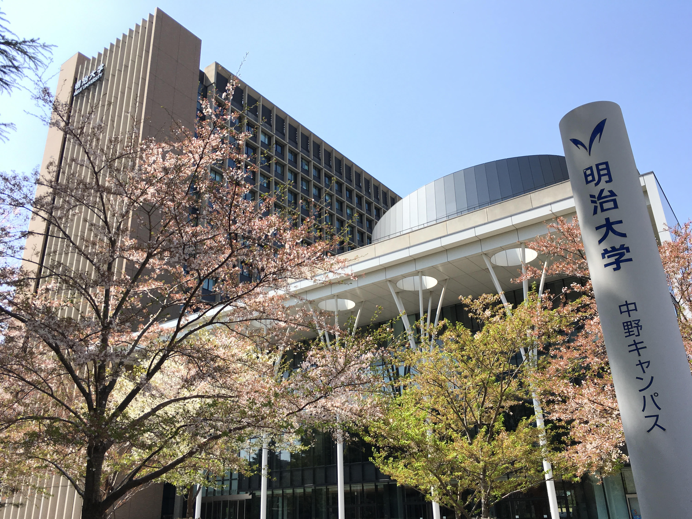
Fig.１： The building of the conference venue. The image is taken by N. J. Suematsu.

Acknowledgements
We acknowledge the people for the discussion.

References
- Authors’ name: “Title of the publication”, Journal name Volume, page number (year).
- Authors’ name: “Title of the publication”, Journal name Volume, page number (year).

